**<http://blast.ncbi.nlm.nih.gov/Blast.cgi?CMD=Web&PAGE_TYPE=Blastdocs>**

**by Cherylann Hollinger**

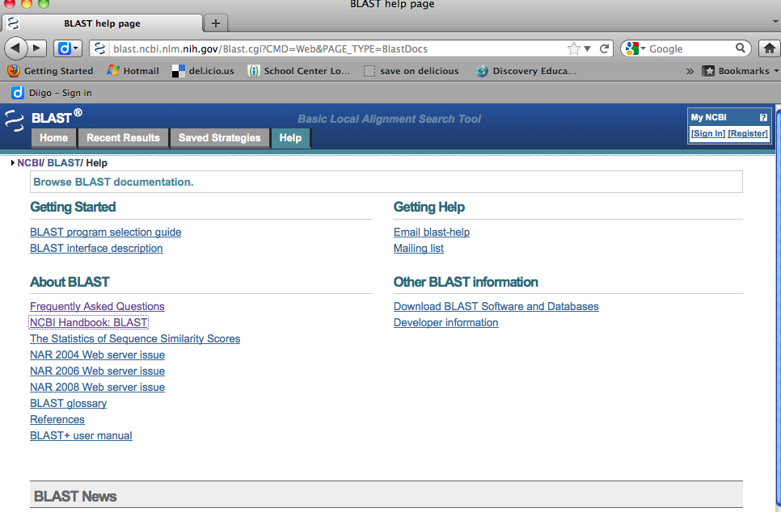

[**http://www.ncbi.nlm.nih.gov/books/NBK21097/**](http://www.ncbi.nlm.nih.gov/books/NBK21097/)

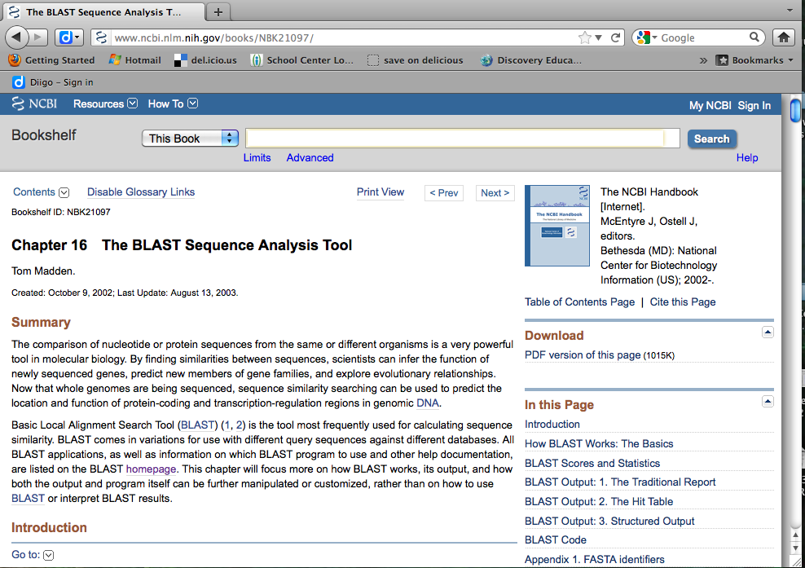

**Excerpt from the BLAST site:**

The way most people use [BLAST](http://www.ncbi.nlm.nih.gov/books/n/handbook/A1237/def-item/app9/) is to input a nucleotide or protein sequence as a query against all (or a subset of) the public sequence databases, pasting the sequence into the textbox on one of the BLAST [Web pages](http://www.ncbi.nlm.nih.gov/BLAST/). This sends the query over the Internet, the search is performed on the [NCBI](http://www.ncbi.nlm.nih.gov/books/n/handbook/A1237/def-item/app116/) databases and servers, and the results are posted back to the person's browser in the chosen display format. However, many biotech companies, genome scientists, and bioinformatics personnel may want to use “stand-alone” BLAST to query their own, local databases or want to customize BLAST in some way to make it better suit their needs. Stand-alone BLAST comes in two forms: the executables that can be run from the [command line](http://www.ncbi.nlm.nih.gov/BLAST/blast_overview.html#executables); or the Standalone [WWW](http://www.ncbi.nlm.nih.gov/books/n/handbook/A1237/def-item/app197/) [BLAST Server](http://www.ncbi.nlm.nih.gov/BLAST/blast_overview.html#wwwserver), which allows users to set up their own in-house versions of the BLAST Web pages.

There are many different [variations](http://www.ncbi.nlm.nih.gov/blast/html/BLASThomehelp.html) of [BLAST](http://www.ncbi.nlm.nih.gov/books/n/handbook/A1237/def-item/app9/) available to use for different sequence comparisons, e.g., a [DNA](http://www.ncbi.nlm.nih.gov/books/n/handbook/A1237/def-item/app37/) query to a DNA database, a protein query to a protein database, and a DNA query, translated in all six reading frames, to a protein sequence database. Other [adaptations](http://www.ncbi.nlm.nih.gov/BLAST/producttable.html) of BLAST, such as [PSI-BLAST](http://www.ncbi.nlm.nih.gov/books/n/handbook/A1237/def-item/app148/) (for iterative protein sequence similarity searches using a position-specific score matrix) and [RPS-BLAST](http://www.ncbi.nlm.nih.gov/books/n/handbook/A1237/def-item/app159/) (for searching for protein domains in the Conserved Domains Database, [Chapter 3](http://www.ncbi.nlm.nih.gov/books/n/handbook/ch3/)) perform comparisons against sequence profiles.

This chapter will first describe the [BLAST](http://www.ncbi.nlm.nih.gov/books/n/handbook/A1237/def-item/app9/) architecture—how it works at the [NCBI](http://www.ncbi.nlm.nih.gov/books/n/handbook/A1237/def-item/app116/) site—and then go on to describe the various BLAST outputs. The best known of these outputs is the default display from BLAST Web pages, the so-called “traditional report”. As well as obtaining BLAST results in the traditional report, results can also be delivered in structured output, such as a hit table (see below), [XML](http://www.ncbi.nlm.nih.gov/books/n/handbook/A1237/def-item/app198/), or [ASN.1](http://www.ncbi.nlm.nih.gov/books/n/handbook/A1237/def-item/app5/). The optimal choice of output format depends upon the application. The final part of the chapter discusses stand-alone BLAST and describes possibilities for customization. There are many interfaces to BLAST that are often not exploited by users but can lead to more efficient and robust applications.

[**http://blogging4biology.edublogs.org/2010/08/28/college-board-lab-files/**](http://blogging4biology.edublogs.org/2010/08/28/college-board-lab-files/)

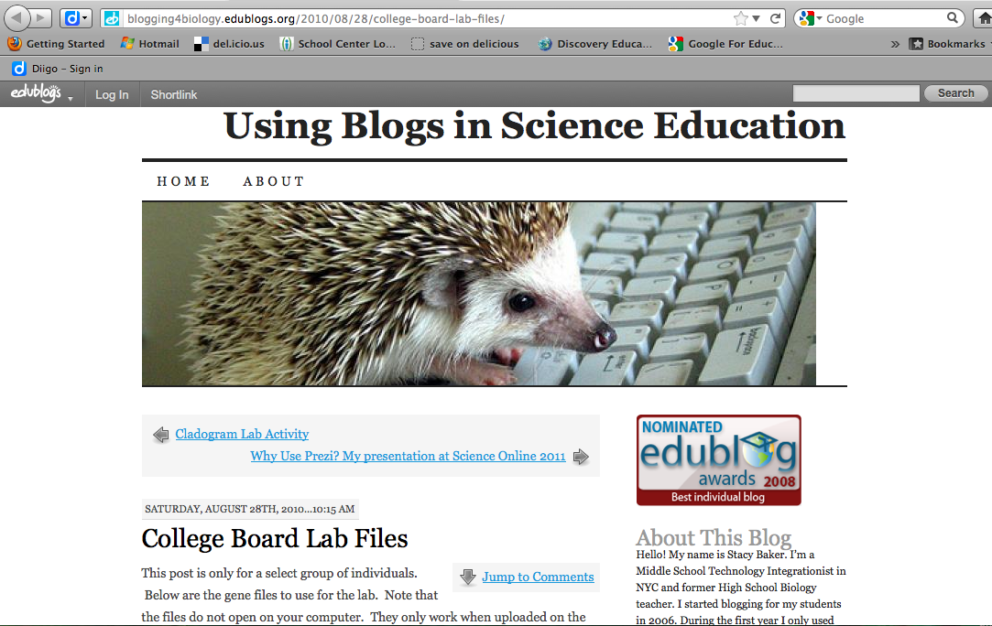

Download 3 gene files, but do not try opening any on computer. Files can only be seen when uploaded to BLAST site.

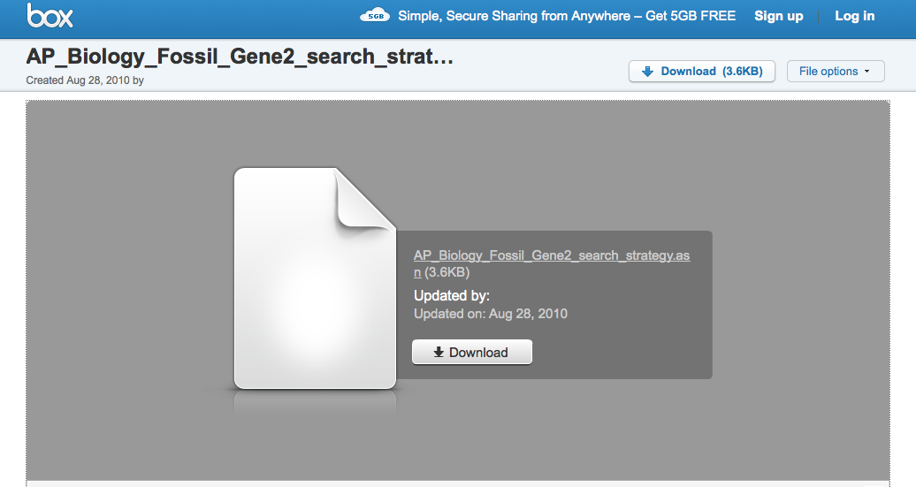

**Go to BLAST site. Click on “Saved Strategies”**

**<http://blast.ncbi.nlm.nih.gov/Blast.cgi>**

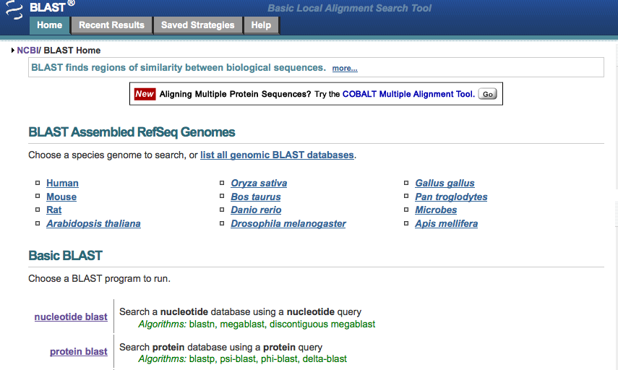

**Under “Upload Search Strategy” click on “Browse” and locate one of the gene files saved on computer. Click “View.”**

**This is what you will see.**

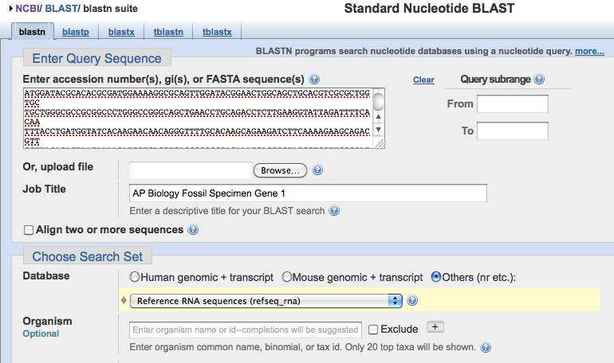

**Nucleotide Sequence of first gene**

**Click on “View” and upload a file. You cannot view the file on your computer.**

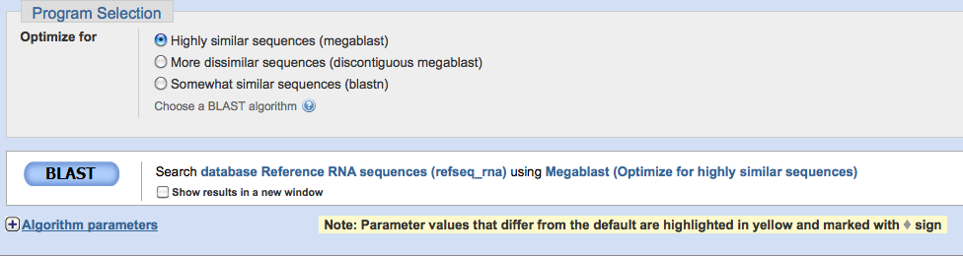

**Click on BLAST button at the bottom of the page.**

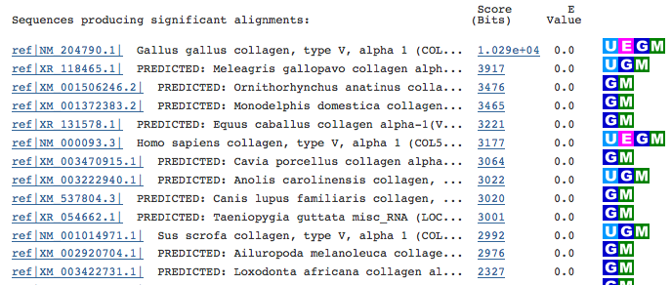

**These are the results that you want to look at first. The species in the list that appears in this section are those with sequences identical to or most similar to the gene of interest. The sequences become LESS similar are you go down the list.**

**Click on a particular species to find out more specific information, including the classification scheme and the sequence of bases that appear to align with your gene of interest.**

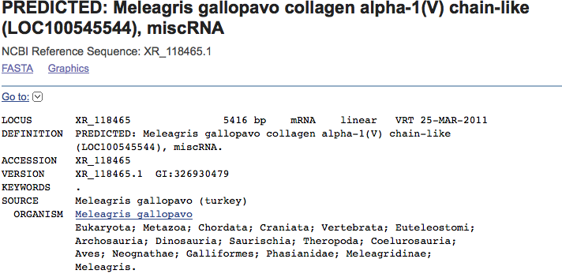

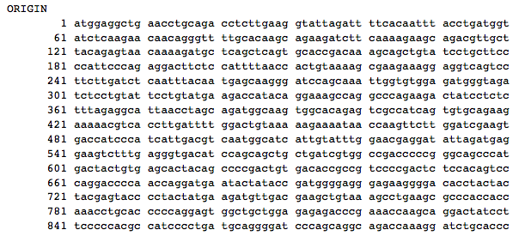

**Click on the “Distance tree of results” link and you will see a cladogram with the species with similar sequences to your gene of interest placed on the cladogram according to how closely their matched gene aligns with your gene of interest.**

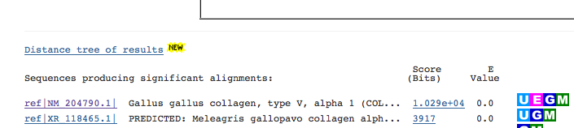

**This is what you will see. Your gene of interest is highlighted in yellow.**

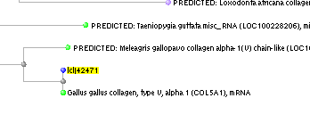

**In addition, you will be provided with a “BLAST names color map” that looks like this so that you can better understand the cladogram your search produced.**

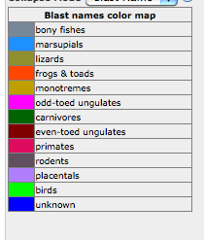

**Other good sites include SWAMI and ENSI.**

